**Chapter 1: Introduction**

**1.1 Problem Statement**

The path of a child is set right with proper directions from parents/guardians, schools/institutions s/he receives over the years from infant to adulthood. Decision making is a constant aspect of livelihood and choices have impacts, which are either positive or negative. Educational guidance is a process of accomplishing student targets, identifying future personality development processes and selection of professional desires in school (Subasinghe, 2016).

Atsuwe and Achebulu (2018) in their work “The influence of Guidance and Counselling on academic performance of Secondary School Students in Makurdi Local Government Area, Benue State” established their findings on the effects seen/experienced by students who received guidance and counselling against those who did not have the opportunity to. The analysis of the data collected in the form of questionnaires and interviews of teachers, guidance counsellors and students showed that students who received Guidance and Counselling had a better academic performance, insight to suitable career choices and behavioral norms as compared with students who did not have the opportunity to receive Guidance and Counselling.

Nzeleni (2015) revealed that the infusion of guidance, counselling and mentoring into a child’s educational background produces a decision-making individual, confident in making own choices regarding preferred career path, behavior, academic excellence, psychological and mental well-being.

Lack of Guidance, Counseling and Mentoring in adolescents (students in secondary schools) has resulted in increase of unpleasant outcomes in the society. These include school dropouts, drug abuse, crimes, poor academic performance, wrong career choices, behaviors, morals and even failure to secure jobs. According to Odeke (as cited in Eliamani et al., 2014), without sound guidance and counseling, students loose direction and engage themselves in bad behaviors such as drug abuse, alcohol indulgence, missing classes, dropout and so on; as a result they lack both, focus and direction resulting in total failure in life.

A lot of Secondary schools in Nigeria fail to implement the inclusion of Guidance, Counselling and Mentoring. Rather, this crucial responsibility is left to Higher education system, ignoring the fact that Guidance, Counselling and Mentoring knows no age boundary. The exemption of Guidance, Counselling and Mentoring in Secondary schools gives loopholes for problems to be carried on further as child grows. Preventative measures can be taken early enough that would avoid/fix issues that set a drawback in the child’s choices/academic excellence, but when there is little or no facility to treat such issues, it evolves with the child into phases of life. Educational guidance is a process of accomplishing student targets, identifying future personality development processes and selection of professional desires in school (Subasinghe, 2016). Thereby, educational guidance in post-primary schools is a very important school activity that should be integrated into all school programs of any country.

**1.2 Background Information**

Guidance in schools “refers to a range of learning experiences, provided in developmental sequence that assist students to develop self-management skills, which will lead to effective choices and decisions about their lives. It encompasses the three separate, but interlinked areas of personal and social development, educational guidance and career guidance.” (DES, 2005).

A study by Hapuarachchi and Samarasinghe (as cited in Subasinghe, 2016) defines counselling as a subject field that tries to solve various social-mental problems, investigating them from a psychological view, enabling people to overcome them through educational guidance, knowledge and through a course of mental therapy. Counselling deals with psychology, which is the study of the mind and behaviour of people. Its objective is to empower psycho-social development of a person.

According to Mullen (2009), mentoring is a behaviour that seeks to enhance the education of protégés outside the traditional supervisory or advisory context. Mentoring deals with learning from a more experienced/knowledgeable person, outside the supervisory text of a classroom.

Peer mentoring schemes involve experienced students supporting and guiding first-year students, helping them to integrate into university life. Such programs are related to enhanced satisfaction with the university learning experience, reduced anxiety, and increased academic performance (Burton, et al., 2013).

The concept of Guidance and Counselling has been used interchangeably, but in recent times scholars have argued that they are two different entities. Subasinghe (2016) argued that the psychological understanding the counsellor possess is a distinguishing tool that the counsellor has over a guidance personnel. The role of counselling is to pave the way to reveal the possibility of identifying the lifestyle of each person, according to their behaviour. The process of solving problems includes gaining a proper understanding about the problem, assess it, evaluate it, and find solutions with regular follow-up.

Guidance work is preventative and developmental in nature, whereas counselling is more supportive and a remedial work (Lai-Yeung, 2014).

Historically,the concept of guidance, counselling and mentoring originated in the 1890’s and was looked up as “Vocational Guidance”. The aim was to provide assistance to young people to help build their skill sets and guide them into the workforce to become productive members of the society. Frank Parsons is often credited with being the father of the Vocational Guidance movement. His work with the Civic Service House led to the development of the Boston Vocation Bureau, which helped outline a system of vocational guidance in public schools. The work of the bureau influenced the need for and the use of vocational guidance, both in the United States and other countries.

The European Community’s first major policy attention to what was then termed “Vocational Guidance” was adopted by European governments in the 1961 European Social Charter, which was signed in Turin to begin effective implementation in February 1966 across Europe (Council of Europe, 1961).

The work of Wrenn (1962) in his book “The Counselor in a Changing World”, brought to light the need for more cultural sensitivity on the part of school counselors. The author recommended a blueprint for school counselling via a holistic school approach. The author further stated that “we must understand the new social forces that are influencing young people, as well as the rest of us and we must learn to apply new psychological insights into the nature of the individual”.

A report by Cassells (2018) gave an insight about the Institute of Guidance Counsellors (IGC) in Ireland, which was founded in 1976 and aimed at representing those working in the field of guidance. It brought all the guidance and counselling associations and organisations together into one organisation. The merging of the various organisations, representing those working in the field of guidance, went very smoothly and soon gained widespread support. In 1969, the Institute published a booklet, titled “The Case for Proper Guidance”, which outlined the various areas of guidance and counselling and how they should be applied in the school situation.

The Organisation for Economic Co-operation and Development (OECD) considers guidance within education system as having an important role to play in laying the foundations for lifelong career development, including knowledge and competencies, regarding self-awareness, the world of work, making decisions and transitions. It defines guidance services as services that assist individuals of any age and at any point throughout their lives to make educational, training and occupational choices and to manage their careers. It stresses that effective advice and guidance on educational and training options and on links between these options and later occupational destinations can help better match individuals’ learning choices to their interests, talents and intended destinations (OECD, 2004). In the OECD‘s view, this can help to reduce early school leaving, improve flows between different levels of education and improve transitions from education to the labour market - these outcomes help to make better use of educational resources and to increase both, individual and social returns to investments in education.

Watts and Fretwell, (2004) argued in their book that the implementation of guidance and counselling into school systems has an overall effect on the social-economic status of the nation. The ability for individual to successfully go into the right career path for the love of a chosen field is crucial, because when an individual loves his/her job, there is diligence, a zeal in doing it and yields great end results with economic growth/profitability. The authors defined career guidance and orientation services as services intended to assist individuals of any age and at any point throughout their lives, empowering them to make educational, training and occupational choices and to manage their careers. The authors illustrated three main elements in their paper: career information, career counselling and career education. Career guidance in schools usually focuses on career information that provides information on courses, occupations and career paths.

It is necessary to assist young people to be disciplined and be able to deal with challenges and realities they face in their ever-changing environment, understand themselves, their academic, social and physical environment, realize their potentials, as well as identify opportunities in a world where chances for further training and employment exist.

Learning from experience is fundamental to personal development and the needs of students to evolve over the stages of the lifecycle (Lizzio & Wilson, 2004). The historical perspective of Guidance, Counselling and Mentoring points to the fact that it is vital to have these services provided in schools during the child’s early education. Exempting children away from early participation would only create more problems in society in terms of preferred career path, academic proficiency, moral and behavioural norms and social-economic effects on the nation in the long run.

The Irish National Development Plan 2000-2006 (IDPER,1999) states that the provision of Guidance and Counselling in Second level schools is vital to enable each pupil to gain the maximum benefit from the education system. The NDP also identifies the school guidance service as a social inclusion measure within the education sector.

The literature regarding school-based mentoring helps to improve connectedness to school, facilitate peer support and improve academic outcomes for participants (Karcher, 2007). Karcher (2007) points to the need for well-structured program that includes mentor selection, mentor and mentee training, clear expectations, a structured approach, activities, supervision of matches, formal endings and agency support. The application of a peer mentoring system in Secondary schools will help first year students/students in general that have special needs/academically slow students to catch-up with their studies through the assistance of a mentor (a student academically proficient).

**1.3 Project Goal**

The Goal of the current Project is to investigate into the needs of Guidance Counsellors, Teachers, Students, Student advisers and Parents in order to develop an appropriate Web Application that can be used to provide access to an Online Guidance, Counselling and Mentoring System in Secondary Schools.

The intended Web Application will provide a communication platform between all parties involved, where cases can be lodged in, sent for analysis to guidance and counsellor office, sorted out according to needs, forwarded to appropriate personnel to handle them, with subsequent follow-ups and progress monitoring records. The Online Guidance, Counselling and Mentoring system will help facilitate the school’s interoperability with its database for students to access Guidance, Counselling and Mentoring services, based on individual needs.

An administrative staff would be in charge for making updates about new cases and forward them to the Guidance and Counsellor office. The system will be available to the Guidance and Counsellor personnel as well as Mentors, Students and Teachers, where a structured communication channel would be established and student’s needs (academic, personal, mental) will be addressed properly by the right personnel, suitable for a case. The system would provide for a good follow up on current cases and monitor improvements. Report generation would be available as well to document the process of development and improvement.

**1.4 Project Objectives**

The objectives of the project include:

* Identify aspects of guidance, counselling and mentoring that the school’s management is interested in
* Gather opinions from Guidance Counsellors, Teachers and Student Advisers through Structured Interviews
* Gather information through a Survey Questionnaire on student parents’ opinion about their perspective on Guidance, Counselling and Mentoring in their children’s school
* Critically analyze the results from Parents Survey and the Structured interviews with school’s Guidance Counsellors, Teachers and Student Advisers
* Specify and structure the functionalities of the application to be developed
* Prepare the First Thesis draft
* Design, code and test the Online Guidance, Counselling and Mentoring Web Application
* Perform User Evaluation of the completed application
* Critically analyze and discuss the results of the Evaluation process
* Provide Conclusions and Recommendation for future work
* Prepare Thesis Second draft
* Prepare Project Presentation slides
* Submit Thesis and present the Project

**1.5 Project Scope**

The project is to investigate into the needs of Queen Ede Secondary School and Western Boys High School in Nigeria of online Guidance, Counselling and Mentoring system in order to develop an appropriate web application for use in these schools. Both secondary schools are approximately 1km apart, within the Ikpoba Okha government area of Edo State, Nigeria.

**1.6 Project Research Methodology and Evaluation Criteria**

A chosen research methodology provides a guide for the researcher on how to collect data effectively and make decisions based on the collected data in line with the projects’ goal. Using an appropriate methodology provides familiarity with a phenomenon to the researcher or ways to achieve new insights into it (study of the project), provides the necessary data and directives in order to develop the required project.

It is vital for the current Project to collect accurate data as it will help in the overall process of achieving the functionality of the application to be developed, as desired by its target audiences.

Alshenqeeti (2014) recommended that researchers should choose the method that answers their research questions best, taking into consideration that the more accurate the researchers are when collecting and analysing the data, the more accurate the findings would be.

**1.6.1 Quantitative Research Method**

Creswell (2013), defines a Quantitative research method as an approach for testing objective

theories by examining the relationship among variables. The variables in this research method can be measured typically with statistical instruments, so that numbered data can be analysed using statistical procedures.

Babbie (2010) describes Quantitative research method as one, which emphasizes objective measurements and the statistical, mathematical, or numerical analysis of data collected through polls, questionnaires, and surveys, or by manipulating pre-existing statistical data, using computational techniques. Quantitative research focuses on gathering numerical data and generalizing it across groups of people, or to explain a specific phenomenon.

The Quantitative research method has the following characteristics:

* The data is usually gathered using structured research instruments.
* The results are based on larger sample sizes that are representative of the population.
* The research study can usually be replicated or repeated, given its high reliability.
* Researcher has a clearly defined research question to which objective answers are sought.
* All aspects of the study are carefully designed before data is collected.
* Data are in the form of numbers and statistics, often arranged in tables, charts, figures, or other non-textual forms.
* Project can be used to generalize concepts more widely, predict future results, or investigate causal relationships.
* Researcher uses tools, such as questionnaires or computer software, to collect numerical data.

**1.6.2 Qualitative Research Method**

According to Creswell (2013), Qualitative research is an approach for exploring and understanding the meaning that individuals or groups ascribe to a social or human problem. The process of research involves emerging questions and procedures, data is typically collected in the participant’s setting, data analysis is inductively building from particulars to general themes, and the researcher is making interpretations of the meaning of the data. It involves direct observation of participants (people of a specific class/area), in-depth interview of participants in a one-one setting or focus groups.

Mack (2005) shows that the strength of Qualitative research is in its ability to provide complex textual descriptions of how people experience a given research issue. It provides information about the “human” side of an issue – that is, the often contradictory behaviours, beliefs, opinions, emotions, and relationships of individuals. Qualitative methods are also effective in identifying intangible factors, such as social norms, socioeconomic status, gender roles, ethnicity, and religion, whose role in the research issue may not be readily apparent.

The Qualitative research approach produces thick (detailed) description of participants’ feelings, opinions, and experiences and interprets the meanings of their actions (Denzin & Lincoln, 2008). In a Qualitative study, inquirers state research questions, not objectives.

**1.6.3 Mixed Research Method**

The Mixed research method is a combination of both Quantitative and Qualitative research methodology. This method combines the pros of both methodologies and involves the use of |Survey questionnaire and Structured interviews to gather data effectively from the targeted audiences. Creswell (2013) made known that each method (Quantitative and Qualitative) makes up for the limitation of the other, whereby the Quantitative method is used to evaluate a wide range of measurable opinions of a targeted audience, while the Qualitative method captures the open-ended, but concise and small range of targeted opinions.

The term “Mixed methods” refers to an emergent methodology of research that advances the systematic integration, or “mixing,” of Quantitative and Qualitative data within a single investigation or sustained program of inquiry. The basic premise of this methodology is that such integration permits a more complete and synergistic utilization of data than do separate Quantitative and Qualitative data collection and analysis (Wisdom & Creswell, 2013).

**1.6.4 Chosen Research Methodology for the Project**

In order to fully capture the opinions of all parties involved in the study, and address the need for an Online Guidance, Counselling and Mentoring system in Secondary schools, a Mixed Research method was utilized.

The Mixed method allowed for a Structured Interview to be performed with Guidance Counsellors, Teachers and Student Advisers, in order to understand their individual opinions, evaluate the current system (if any present) for carrying out Guidance and Counselling in the school, understand the basic needs they have to make the process better, as well as challenges they face, carrying out their job.

A Survey Questionnaire was also made available to student parents. This assisted in gathering their respective opinions and understand their basic needs for Guidance, Counselling and Mentoring of their children. Quality of service currently provided was investigated, as well as ascertaining opinions about the system in place (if any).

The results of the Structured interview and Survey questionnaire were collected and then critically analysed, considering the following important information for the development of an appropriate Web Application for an Online Guidance, Counselling and Mentoring system:

* Areas identified by school management, parents, student advisers and guidance counsellors/member staff
* Benefits of providing guidance, counselling and mentoring to students

The prototype of the application is then be developed, based on the analyses of these preliminary results from the Structured interviews and Survey questionnaire to gather the system requirements. The Web Application is to be made available to the school’s users (all parties involved) through the school’s Intranet for users’ Evaluation Survey, which is to be conducted to obtain target audiences feedback and make further improvements to the application to make it more robust, fully functional and applicable, based on users’ needs and requirements.

The Evaluation Survey is carried out to address the following key factors:

**Content:** Capture and present intended information in a meaningful way for users’ experience.

**Accessibility:** Availability of the web application to users through the schools’ Intranet. Current and future ability to access the application.

**Navigation:** Clear indication of navigation menu defined for users to easily and clearly access contents.

**Design:** User friendly graphical user interface (GUI) design, having appropriate formatting, styling and readability.

**Security:** Access control for authorised users and protection of the stored sensitive information in the database.

These key factors are considered to indicate user satisfaction, defined problem solution, feasibility and viability of the application for the school. Failure in any aspect is considered as a challenge to find a better solution to make the application more reliable and efficient in order to achieve the projects’ purpose and goal.

**1.7 Project Milestones & Deliverables**

The Project milestones include the following:

* Preliminary investigation into a project topic
* Identify suitable project
* Preliminary literature review for First draft of the Project Proposal
* Complete Project Proposal
* Design and distribute Survey questionnaire and Structured interview questions to target audiences.
* Critically analyze the results of the Survey and the Interviews and complete Thesis Chapter 1: Introduction
* Undertake full Literature review on the topic and complete Thesis Chapter 2
* Analyze requirement specification for the application and complete Chapter 3: Application Analysis phase
* Submit Thesis First draft
* Design the application framework (its GUI and Data structures) and code the application; Prepare Thesis Chapter 4: Application Design and Coding
* Perform intense application testing and complete Chapter 5: Application Testing
* Perform User Evaluation, analyze its results and complete Thesis Chapter 6: Evaluation, results analysis and discussion, conclusion and scope for future work
* Submit Thesis Second draft
* Prepare Project Presentation slides
* Submit Project Dissertation and present completed Project

**1.7.1 Project Deliverables**

* Project Proposal
* Thesis First Draft
* Web Application Source Code
* Thesis Second draft
* Completed Project Dissertation and Project Presentation

**1.8 Project Timeframe**

*Table 1.1: Project Timeframe for Semester 1 and 3*

|  |  |  |  |
| --- | --- | --- | --- |
| **#** | **Milestone** | **Deliverables** | **Duration** |
| 1 | Preliminary project investigation | Research on possible project topics | 26/09/18  -  10/10/18  2 weeks |
| 2 | Identify suitable project | Chosen appropriate research & development project topic | 10/10/19  -  17/10/18  1 week |
| 3 | Preliminary Literature review, Project Proposal writing, | First draft of Project Proposal document | 17/10/18  -  07/11/18  3 weeks |
| 4 | Design of Survey questionnaire and Structured Interview questions | Survey and Interview questions disseminated to samples of suitable study participants | 07/11/18  -  14/11/18  1 week |
| 5 | Finalising the Project Proposal | Project Proposal completed | 14/11/18  -  28/11/18  2 weeks |
| 6 | Respondents completing Survey, and Interviews of teachers, guidance counsellors, student advisers; Completing Thesis Ch.1 | Data collection & results analysis; Ch.1 completed | 28/11/18  -  12/12/18  2 weeks |
| 7 | Full Literature review; Writing Thesis Ch.2 | Completed Literature review; Ch.2 completed | 24/06/19  -  01/07/19  1 week |
| 8 | Choosing appropriate Development methodology and completing application Analysis phase; Writing Thesis Ch.3 | Requirements specification for the application’s functionality; Ch.3 completed | 01/07/19  -  21/07/19  3 weeks |
| 9 | Submit Thesis First Draft | Completed Ch.1, 2 and 3 of the Thesis | 21/07/19  -  22/07/19  1 day |
| 10 | Perform application GUI and Data structures Design and Coding; write Thesis Ch.4 | Storyboard designs for application Screens and design of Database tables; coded application; Ch.4 completed | 22/07/19  -  12/08/19  3 weeks |
| 11 | Application Testing and debugging; writing Thesis Ch.5 | Fully tested Application; Ch.5 completed | 12/08/19  -  19/08/19  1 week |
| 12 | User Evaluation of the developed application and results discussion; writing Thesis Chapter 6 | Feedback from users’ application evaluation and its results analysis; complete Ch.6 | 19/08/19  -  26/08/19  1 week |
| 13 | Submit Second draft of Thesis | Review of Thesis second draft | 27/08/19  -  29/08/19  2 days |
| 14 | Prepare Presentation slides | Power point Presentation slides | 29/08/19  -  31/08/19  2 days |
| 15 | Print and hard bound Dissertation and present the Project | Submitted 3 hard bound copies of Dissertation document; Project presented | 31/08/19  -  02/09/19  2 days |

**1.8.1 RMMM matrix (Risk, Measurement, Monitor, Mitigation)**

*Table 1.2: RMMM Matrix*

|  |  |  |  |
| --- | --- | --- | --- |
| **No** | **Risk Description** | **Impact** | **Action** |
| 1 | Scope of framework may expand | Critical | Limit project scope to specific school’s personnel |
| **2** | Heads of schools may be unwilling to accept the application/make improvements to existing services. | Critical | Focus of school(s) that support the idea |
| 3 | Not completing specific task within its time frame | Critical | Try to finish each task early or adjust time frame |

The Gantt Chart for the Project, reflecting the stipulated Timeframes for Semesters 1 and 3 is

provided in *Appendix A1*.

**1.9 Results Analysis of the Survey Questionnaire and the Structured Interviews**

**1.9.1 Survey Questionnaire for Parents**

Survey Questionnaire, containing sixteen (16) questions was prepared, using Google Forms and distributed to students’ parents in Queen Ede Secondary School and Western Boys High School in Benin City, Nigeria. Both surveyed schools are 1km apart each other within the Ikpoba Okha local government area of the state. A total of **17 parent responses** were obtained.

The Graphical representation of the results of the Parents’ Survey is provided in *Appendix A2.*

**Date Surveyed: 01/12/2018**

To Q1, *“Please, specify your gender”*, 17 responses were recorded. 70.6% of the respondents were identified as Females and 29.4% as Males.

To Q2, *“In what age group are your children?”,* This question provided for multiple answer selection, based on number of children a Parent has in the underlisted schools. 17 responses were received. 9 of the respondents, which accounted for 52.9% were having children between 11-13 years of age, 9 respondents had children between 14-16 years of age, which accounted for another 52.9%, and 2 respondents were having children of 17+ years of age, which accounted for 11.8% of the total respondents.

To Q3, *“In what class are your children?”,* which question provided for multiple answer selection based on number of children a Parent has in the underlisted schools, 17 responses were received, out of which 17.6% (3 respondents) had children in Year 7, 35.3% (6 respondents) had children in Year 8, 17.6% (3 respondents) had children in Year 9, 11.8% (2 respondents) had children in Year 10, 35.3% (6 respondents) had children in Year 11 and 17.6% (3 respondents) had children in Year 12.

To Q4, *“Is there guidance, counselling and mentoring service in your child’s school?”* 17 responses were recorded, from which 76.5% answered *Yes* to the question and 23.5% answered *No*.

To Q5, *“If Yes to Q4, please rate the existing services provided in the school”.* 13 responses were recorded from parents of students in Queen Ede Secondary School, as Western Boys High School doesn’t have the services of Guidance, Counselling and Mentoring. Out of these 13 responses recorded, to 15.4% (2 respondents) the existing service was *Excellent*, to 38.5% (5 respondents) it was *Very good* and to 23.1% each (3 respondents each) it was *Moderate* and *Poor*, respectively.

To Q6, *“How is the existing service provided in the school?”* 13 responses were recorded from parents of students in Queen Ede Secondary School. 92.3% (12 respondents) have chosen *Direct interaction with a counsellor* option as answer, 61.5% (8 respondents) have chosen *Integrated into teaching* option and there was no response with the option *Use of* *Online Web Application*.

To Q7, *“If the service currently provided is via an online web application, please specify features of it and what you best like about it.”* no responses were received.

To Q8, “*What sort of problem(s) have you noticed in your children that you think need(s) to be addressed to the school for assistance?”* Multiple options selection was made available for this question which had 17 responses in total. 70.6% (accounting for 12 respondents out of the total number) have chosen *Bullying/Bullied* option as an answer, 58.8% (10 respondents) have chosen *Social/Mental-health issues* option, 100% of respondents have chosen *Academic support* option and 23.5% (which account for 4 respondents) have chosen the *Substance Abuse* option as an answer.

To Q9, *“In your opinion is Guidance, Counselling and Mentoring needed in Secondary schools?”* 17 responses were recorded, and all respondents (100%) have chosen *Yes* as an answer.

To Q10, *“If you noticed problems with your children’s behaviour or academic proficiency, or other, would you?”* Multiple options selection was provided in the question. 17 responses were recorded, out of which 35.3% (accounted for 6 respondents) have chosen *Refer to the school’s counsellor* option, 41.2% (7 respondents) have chosen *Deal with them yourself at home* option, and 23.4% (4 respondents) have chosen *All of the above* option as an answer.

To Q11, *“If you rather refer the problem(s) detected to the right department, please specify how would you want the services to be provided?”* 16 responses were recorded, of which 93.8% (15 respondents) have chosen *A web application* and *direct interaction* *plus a follow up system* as an answer, and 6.3% (1 respondent) has chosen *Direct interaction* option as an answer.

To Q12, *“Do you know of any existing web application(s) that provide a communication platform for parents, guidance counsellors and students to discuss problem(s) identified?”*

17 responses were recorded and all respondents (100%) answered *No* to that question.

To Q13, *“If you answered “Yes” to Q12, please provide the title and URL of such application.”* Zero responses were received.

To Q14, *“Would you be interested in a specially designed web application that can in one platform provide communication between all interested parties to resolve student problems, faced at school?”* 17 responses were recorded and all respondents (100%) have answered *Yes* to that question.

To Q15, *If you answered Yes to Q14, what features/functionalities would you like to have in such an application?”* Multiple options selection was provided for which 17 responses were recorded. 94.1% (accounting for 16 of 17 respondents in total) have chosen the options: *Parent Registration and Login*; *Create a request for a case online;* and *Get updated reports about progress of the child*. All respondents (100%) have chosen *Get notification once case is opened* and 15 out of the 17 respondents, which accounts for 88.2%, have chosen *Book appointment*.

To Q16, *“In your opinion, would such specially designed web application be an efficient and useful tool for easy relation of a child’s problem to the counselling department, review of the problem and monitor the progress achieved?”* 17 responses were recorded out of which 70.6% (12 respondents) have chosen *Yes* as an answer and 29.4% (5 respondents) have chosen *Maybe*.

**1.9.2 Structured Interview with Guidance Counsellors and Teachers of the schools**

A structured interview, containing seventeen (17) questions was prepared, using Google Forms and distributed to Guidance Counsellors and Teachers of Queen Ede Secondary School and Western Boys High School. Both schools that had their staff members interviewed are 1km apart from each other within the Ikpoba Okha local government area of the state. A total of **7 responses** were obtained. The Graphical representation of the results of the Interviews with Guidance Councellors and Teachers of both schools is provided in *Appendix A3.*

**Date Interviewed: 11/03/2019**

Q1 - Q4 gathered personal information about the participants (Participant’s name, Name of the School, Position/Role held there, Subject(s) they teach there).

*Table 1.3: Names and Subjects Taught by participants in the Structured Interview*

|  |  |  |  |
| --- | --- | --- | --- |
| Name | Name of School | Position | Subject(s) Taught |
| Mrs Grace Idahosa | Queen Ede Secondary School | Grad Senior Master 1 | Guidance and Counselling |
| Mrs Jane Idemudia | Western Boys High School | Grad Master 1 | Biology |
| Mr Odigie Osagie | Queen Ede Secondary School | Grad Master 1 | Mathematics |
| Mrs Mary Obeahon | Queen Ede Secondary School | Grad Senior Master 2 | Guidance and Counselling |
| Mrs Vivian Oguamanam | Western Boys High School | Grad Master 2 | English Language |
| Frank Maduka | Queen Ede Secondary School | Grad Master Lv 8 | Physics |
| Mr Patrick Ogbeide | Western Boys High School | Principal 1 Lv 15 | Chemistry |

To Q5, *“Is there guidance, counselling and mentoring services in your school?”* 7 responses were recorded of which 57.1% (4 out of the 7 respondents) have answered *Yes* (the participants from Queen Ede Secondary School) and 42.9% (3 out of 7 respondents) have answered *No* (the participants from Western Boys High School).

To Q6, *“How will you rate the guidance, counselling and mentoring services in your school?”* 4 responses were recorded of which 75% (3 respondents) have chosen *Good* option as an answer and 25% (1 respondents) has chosen *Fair* option as an answer.

To Q7, *“Please state what services are offered by the existing system”.* 4 responses were recorded:

Response 1: *Career Guidance, Academic Support and Moral Support*.

Response 2: *Career guidance, Academic support*.

Response 3: *Academic support, Career guidance, Moral support, Mental & Health wellbeing*. Response 4: *Academic support and Career guidance*.

To Q8, *“In your opinion, is guidance, counselling and mentoring needed in the school?”* 6 responses were recorded, and all respondents have chosen *Yes* option as an answer.

To Q9, *“What kind of problems do you normally encounter with students that require guidance, counselling and mentoring?”* Multiple options selection was made available. 7 responses were recorded of which:

all 7 respondents (accounting for 100%) selected: *Academic support*, *Social/Mental-health issues*, *Bullying and Career choice*.

42.9% (3 respondents) selected *Issues at home*;

57.1% (4 respondents) selected *Substance abuse*, and

14.3% (1 respondent) selected *Suicide, attempts to drop out of school*.

To Q10, *“What challenges do you face in the course of offering guidance, counselling and mentoring services in your school?”* 4 responses were recorded:

Respondent 1: *Parental influence on student's career choice and Overwhelming number of students to counsellor ratio*;

Respondent 2: *Budget limit of the department*;

Respondent 3: *Low budget provided for the department, Parents influence career choice of students*, and

Respondent 4: *Thin budget of the guidance and counselling department*.

To Q11, *“Do you know of any online application(s) for guidance, counselling and mentoring?”* 7 responses were recorded, of which 5 respondents (71.4%) have answered *No* and 2 respondents (28.6%) who are Guidance and Counsellors in Queen Ede Secondary School have answered *Yes*.

To Q12, *“If you answered “Yes” to Q11, please provide the title and URL of such application.”* 2 responses were recorded, and both are Guidance and Counsellors in Queen Ede Secondary School. The answers provided were:

BetterHelp <https://www.betterhelp.com>

turn2me <https://turn2me.org>

To Q13, *“If you answered “Yes” to Q11, please list some features and functionalities you liked in such an application.”* 2 responses were recorded:

Response 1: *Questionnaire to understand the individual, Chat, Phone and Video sessions, Choice between online session or in-office visit*;

Response 2: *Support groups, 1-on-1 sessions with counsellor online, Questionnaire before each session.*

To Q14, “*In your opinion, would a specially designed web application, providing an online guidance, counselling and mentoring system be useful in your school?”* 7 responses were recorded, and all respondents (100%) have answered *Yes*.

To Q15, *“If you have answered ‘'Yes'' to Q14, what features would you like to see in such specially designed application?”* Multiple options selection was made available. 7 respondents were recorded, with all participants (100%) selecting *Registration and login, view appointed cases, create appointment for students, send messages and Generate reports* options. 22.6% (accounted for 2 respondents) selected *Online sessions with voice and video communication* option.

To Q16, *“In your opinion, would such an Online guidance, counselling and mentoring web application improve the existing services offered by the school’s guidance and counselling department?”* 7 respondents were recorded, of which 85.7% (6 respondents) answered *Yes* and 14.3% (1respondent) answered *Maybe*.

To Q17, *“In your opinion, could such web application become a standard system for offering guidance, counselling and mentoring services in your school?”* 7 responses were recorded, of which: 57.1% (accounting for 4 respondents) answered *Yes* and the rest 42.9% (3 respondents) answered *Maybe*.

**1.9.3 Summarized Results of both, the Structured Interviews and the Survey**

Based on a total of 24 responses from Parents, Teachers and Guidance Counsellors, a critical analysis through Google Forms results of the Survey Questionnaire and Structured Interviews was performed and the following summarized information was obtained:

* 52.9% of the Parents surveyed had their children between 11-13 years of age and 14-16 years, while 11.8% accounted for those in the age group of 17+. The classes of the parent’s children from the Survey showed that 35.3% were in Years 8 and 11; 17.6% were in year 7, 9 and 12; while 11.8% were in year 10.
* Guidance, Counselling and Mentoring Services is present only in Queen Ede Secondary School. 23.5% of the Parents who chose the *non-existence* of Guidance, Counselling and Mentoring Services in their children’s school, have their children attending Western Boys High School.
* Parents made ratings of the existing Guidance, Counselling and Mentoring Services in their children’s schools as follows; *Excellent* (15.4%), *Very good* (38.5%), and 23.1% as *Moderate* and *Poor*, each. Teachers and Guidance Counsellors of Queen Ede Secondary School made ratings of existing Guidance Counselling and Mentoring service as follows: *Good* (75%) and *Fair* (25%).
* Guidance, Counselling and Mentoring Services in Queen Ede is mostly provided via *Direct interaction with a counsellor* and as being *integrated into the teaching process*. There is *no use* of a Web Application to provide Guidance, Counselling and Mentoring Services.
* Problems that required Guidance, Counselling and Mentoring Services in schools as revealed by Parents include: *Academic support* (100%), *Bullying* (70.6%), *Social/Mental-health issues* (58.8%) and *Substance Abuse* (23.5%). Problems that required Guidance, Counselling and Mentoring Services in schools as revealed by Teacher and Guidance Counsellors include: *Academic support* (100%), *Social/Mental-health issues* (100%), *Bullying and Career choice* (100%), *Issues at home* (42.9%), *Substance abuse* (57.1%), *Suicide and attempts to drop out of school* (14.3%).
* The major problems encountered by Teachers and Guidance Counsellors in carrying out their jobs in respect to providing Guidance, Counselling and Mentoring Services are *little/thin (insufficient) budget allocation to the Guidance and Counselling department*, *Parental Influence on child’s career choice* and the *overwhelming number of students to Guidance Counsellors ratio*.
* Only Guidance and Counsellors are aware of similar Web Applications that can be used to provide an Online Guidance, Counselling and Mentoring Service. Highlighted features of existing systems as revealed by Guidance Counsellors which they liked are: *Questionnaire to understand the individual*, *Chat*, *Phone*, *Video sessions*, Choice between *Online session* or *in-office visit*, *Support groups*, *1-on-1 sessions with Counsellor online*.
* All Parents (100%) wanted the feature of *getting notification once a case is opened*, 88.2% of Parents wanted to be able to *book appointment* with the Web Application, 94.1% wanted features such as *Parent Registration and Login*, *create request for a case online* and *Get updated reports about progress of the child*.
* All Teachers and Guidance Counsellors (100%) wanted the functionalities/features of the Online Guidance, Counselling and Mentoring Web Application to contain: *Registration and Login*, *View appointed cases*, *Create appointment for students*, *Send messages* and *Generate reports*. 22.6% wanted added features such as *Online sessions with voice and video communication*.
* Based on 7 respondents (Teachers and Guidance Counsellors), 85.7% of them have answered with *Yes* that an Online Guidance, Counselling and Mentoring Web Application will improve the existing services offered by the school’s Guidance and Counselling department, while 14.3% have answered with *Maybe* that question. 57.1% of Teachers and Guidance Counsellors *have agreed* that such web application can become a standard system for offering Guidance, Counselling and Mentoring services in the school, while the rest (42.9%) have chosen *Maybe* as an answer. 70.6% of the parents have answered with *Yes* that such specially designed web application will be an efficient and useful tool for easy relation of a child’s problem to the counselling department, review of the problem and monitor the progress achieved, while 29.4% have chosen *Maybe* as an answer.
* All Parents, Teachers and Guidance Counsellors (100%) revealed that Guidance, Counselling and Mentoring is important in Secondary Schools and they showed interest for the development of an Online Guidance, Counselling and Mentoring Web Application as they revealed it will be a useful tool to the Guidance and Counselling department.

**1.10 Chapter Summary**

In this chapter, the problem statement was clearly revealed with the researcher providing a clear structure of the project’s goal and objectives. With the use of the Mixed Research methodology, the researcher was able to gather opinions from the targeted audiences and these were done through Survey Questionnaire and Structured Interviews.

The results were critically analyzed, and showed that there is a demand for the intended for development Online Guidance, Counselling and Mentoring Web Application as the audiences surveyed and interviewed agreed that such a Web Application would improve the services, offered by the Guidance and Counselling department in their schools. The results analysis proved the viability of the project.

A detailed discussion on the Literature review and Case studies on similar already existing applications will be provided in the next chapter.

**References**

Alshenqeeti, H. (2014). Interviewing as a Data Collection Method: A Critical Review. English Linguistics Research, Vol. 3(1), pp. 39-45. (Online) Available at: http://dx.doi.org/10.5430/elr.v3n1p39, Accessed on (14/02/2019).

Atsuwe, B. A., & Achebulu A. O. (2018). The Influence of Guidance and Counselling on academic performance of Secondary Schools Student in Makurdi local government area, Benue State. International Journal of Educational Studies, Vol. 5(2), pp.71-78. (Online) Available at: https://escijournals.net/index.php/IJES/article/view/2542/1260, Accessed on (25/11/2018).

Babbie, E. R.,(2010). *The Practice of Social Research*. 12th ed. Belmont, CA: Wadsworth Cengage, 2010; Muijs, Daniel. Doing Quantitative Research in Education with SPSS. 2nd edition. London: SAGE Publications. (Online) Available at: https://libguides.usc.edu/writingguide/quantitative, Accessed on (21/06/2019).

Burton, L. J., Chester, A., Xenos, S., and Elgar. K. (2013). Peer mentoring: An embedded model to support first year psychology students. Vol. 12(2), pp. 136-146. (Online) Available at: https://journals.sagepub.com/doi/pdf/10.2304/plat.2013.12.2.136, Accessed on (10/11/2018).

Cassells, V. (2018). Institute of Guidance Counsellors: Our History. Institute of Guidance Counsellors. (Online) Available at: http://www.igc.ie/about-us/our-history, Accessed on (05/12/2018).

Council of Europe (1961). European Social Charter. Turin: CVCE Europe, pp.1-18. (Online) Available at: https://www.cvce.eu/content/publication/2003/3/7/e71c737f-4afb-41e3-9426-43bbf1cd0f00/publishable_en.pdf, Accessed on (05/11/2018).

Creswell, J.W.(2013). *Research design: Qualitative, quantitative, and mixed methods approaches*. 4th edition Sage publications.

Denzin, N.K. and Lincoln, Y.S., 2008. *The landscape of qualitative research*. 4th edition Sage Publication .

Department of Education & Science (2005). Annual Report 2005. Dublin: The Ministry of Education, pp.1-50. (Online) Available at: https://www.education.ie/en/Publications/Corporate-Reports/Annual-Report/des_annual_report2005.pdf, Accessed on (04/11/2018).

Eliamani, M. P., Richard, M. L. and Peter, B. (2014). Access to guidance and counselling services and its influence on Students' school life and career choice. African Journal of Guidance and Counselling, Vol. 1(2), pp. 07-15. (Online) Available at: http://citeseerx.ist.psu.edu/viewdoc/download?doi=10.1.1.674.1625&rep=rep1&type=pdf, Accessed on (21/10/2018).

Irish Department of public expenditure and reform (1999). *The National Development plan 2000-2006* (DPER Publication No. 7780). (Online) Available at: https://www.drugsandalcohol.ie/5076/1/NDP_complete_text%5B1%5D.pdf , Accessed on (10/11/2018).

Karcher, M. (2007). Cross-Age Peer Mentoring. Research in Action. Vol. 1(7), pp. 01-24. (online) Available at: https://files.eric.ed.gov/fulltext/ED502220.pdf, Accessed on (10/11/2018).

Lai-Yeung, S.W.C. (2014). The need for guidance and counselling training for teachers. Procedia-Social and Behavioural Sciences, Vol. 113, pp.36-43. (Online) Available at: https://www.researchgate.net/publication/260213093_The_Need_for_Guidance_and_Counselling_Training_for_Teachers, Accessed on (10/11/2018).

Lizzio, A., & Wilson, K. (2004). Action learning in higher education: An investigation of its potential to develop professional capability. Studies in Higher Education*,* Vol. 29(4), pp. 469-488. (Online) Available at: http://reforma.fen.uchile.cl/Papers/Action%20Learning%20in%20Higher%20Education%20&%20Professional%20capability%20-%20Lizzio,%20Wilson.pdf, Accessed on (10/11/2018).

Mack, N., (2005). Qualitative research methods: A data collector’s field guide, (Online) Available at: https://course.ccs.neu.edu/is4800sp12/resources/qualmethods.pdf, Accessed on (21/06/2019).

Mullen, C.A., (2009). Re-Imagining the Human Dimension of Mentoring: A Framework for Research Administration and the Academy. Journal of research administration, Vol. 40(1), pp.10-31. (Online) Available at: https://files.eric.ed.gov/fulltext/EJ886783.pdf, Accessed on (10/11/2018).

Nzeleni, L.P., (2015). *Provision of Guidance and Counselling Services in the Schools in the Transkei Sub-region of the Eastern Cape*. (Online) Available at: https://core.ac.uk/download/pdf/43177037.pdf, Accessed on (28/12/2018).

Organization for Economic Co‐operation and Development. (2004). *Career guidance and public policy: Bridging the gap*. (Online) Available at: http://www.oecd.org/education/innovation-education/34050171.pdf, Accessed on (10/11/2018).

Subasinghe, W. (2016). An Introduction on Educational Guidance and School Counselling. International Journal of Scientific Research and Innovative Technology, Vol. 3(10), pp. 11-18. (Online) Available at: https://www.ijsrit.com/uploaded_all_files/3412481844_b2.pdf, Accessed on (28/10/2018).

Watts, A. G., & Fretwell, D. H. (2004). Public policies for career development: Case studies and emerging information and guidance systems in developing and transition economies. Available at: http://siteresources.worldbank.org/EDUCATION/Resources/278200-1099079877269/547664-1099079984605/PublicPolicy_CareerDev.pdf, Accessed on (10/11/2018).

Wisdom, J. and Creswell, J.W., (2013). Mixed methods: integrating quantitative and qualitative data collection and analysis while studying patient-centered medical home models. Rockville: Agency for Healthcare Research and Quality. (Online) Available at: https://pcmh.ahrq.gov/sites/default/files/attachments/MixedMethods_032513comp.pdf, Accessed on (19/05/2019).

Wrenn, C. G. (1962). *The counselor in a changing world*. Washington, DC, US: American Personnel and Guidance Association. (Online) Available at: http://psycnet.apa.org/PsycBOOKS/toc/13132, Accessed on (02/12/2018).

**Appendix A1: *Project Gantt Chart***

**Appendix A2: *Graphical Representation of the Survey Results***

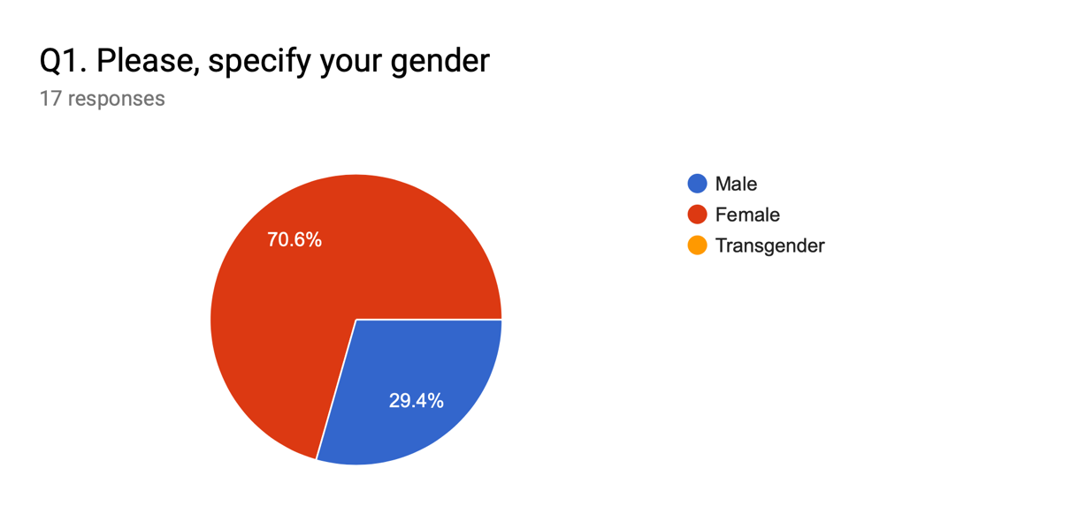

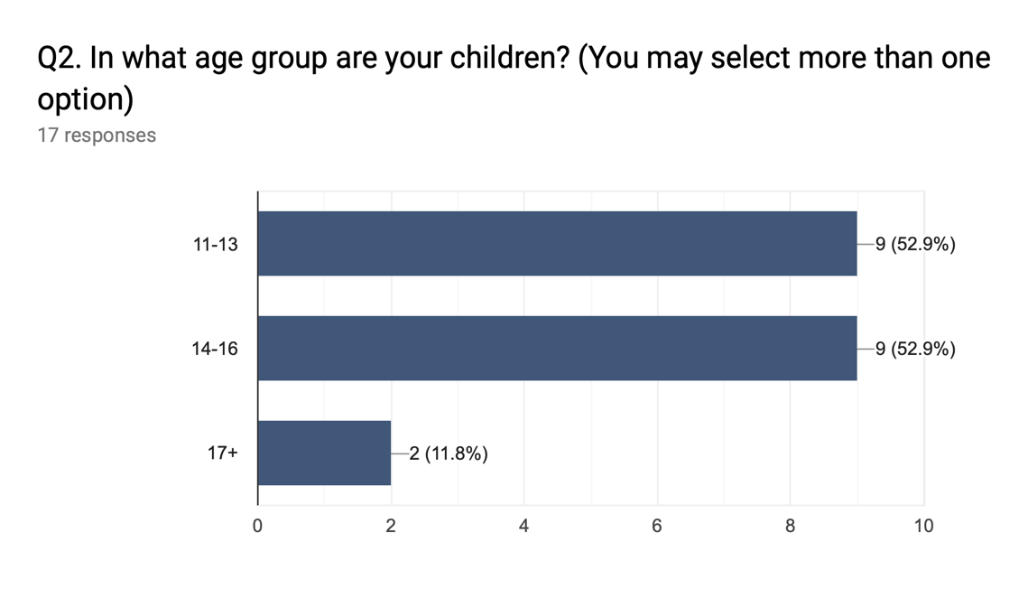

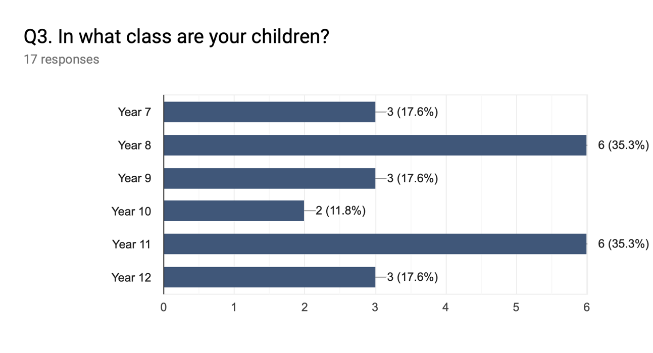

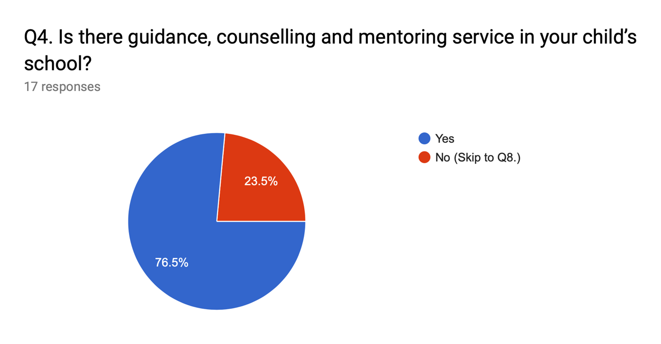

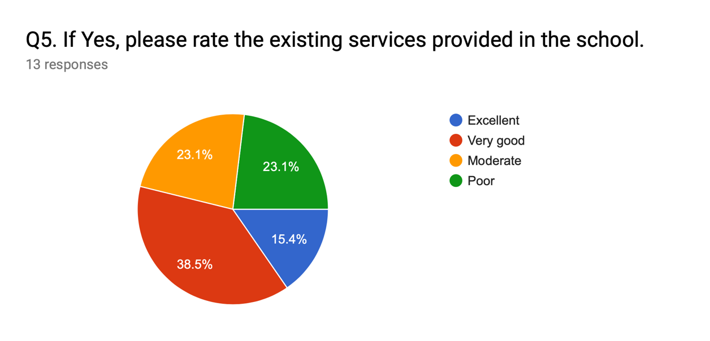

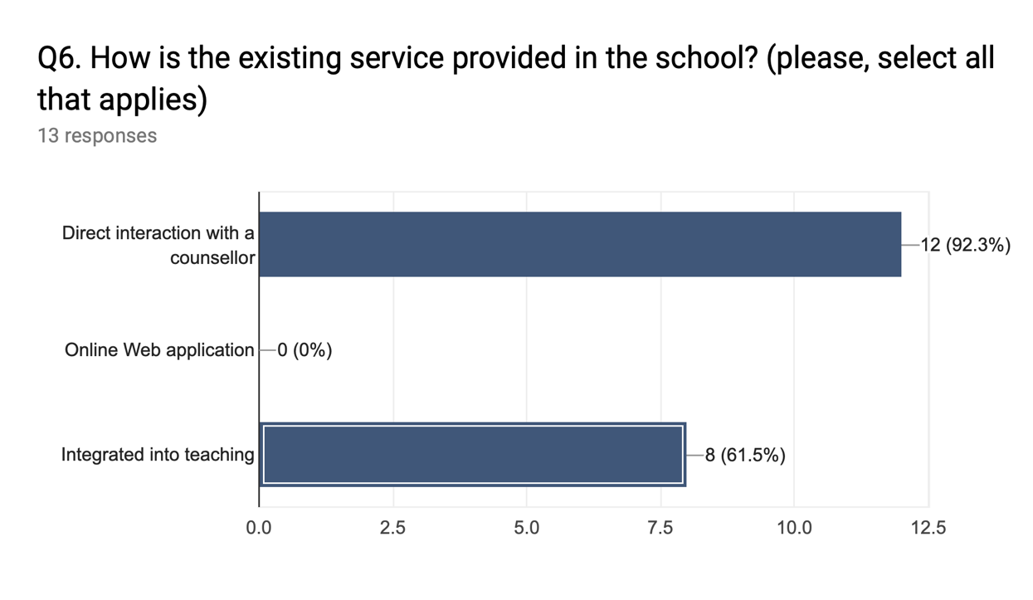

Q7. If the service currently provided is via an online web application, please specify features of it and what you best like about it.

0 responses

No responses yet for this question.

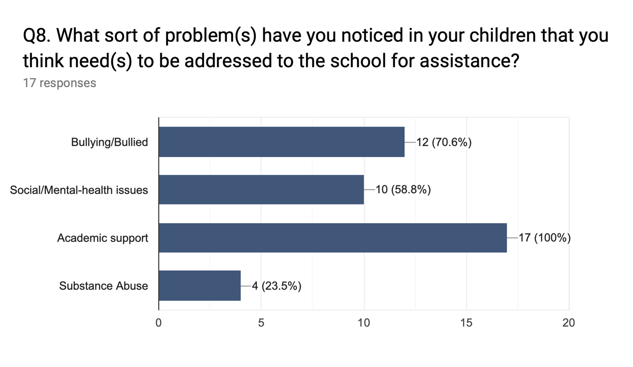

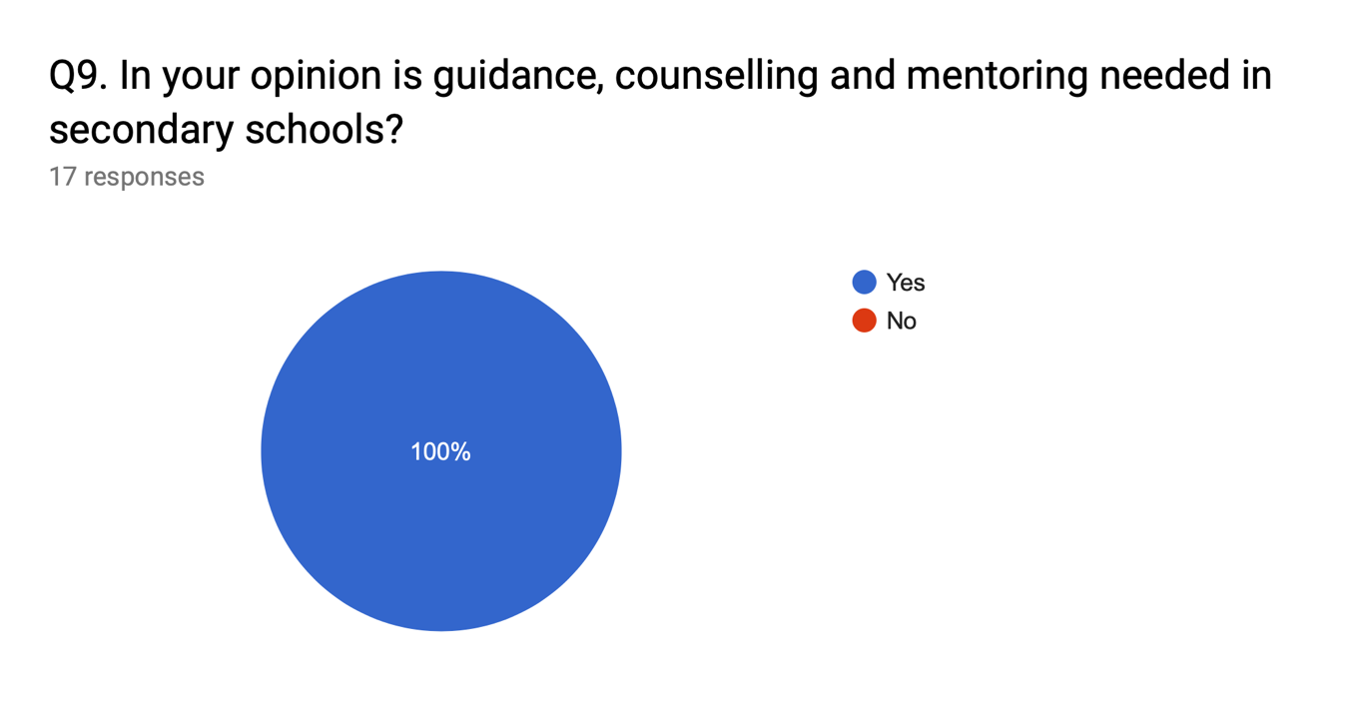

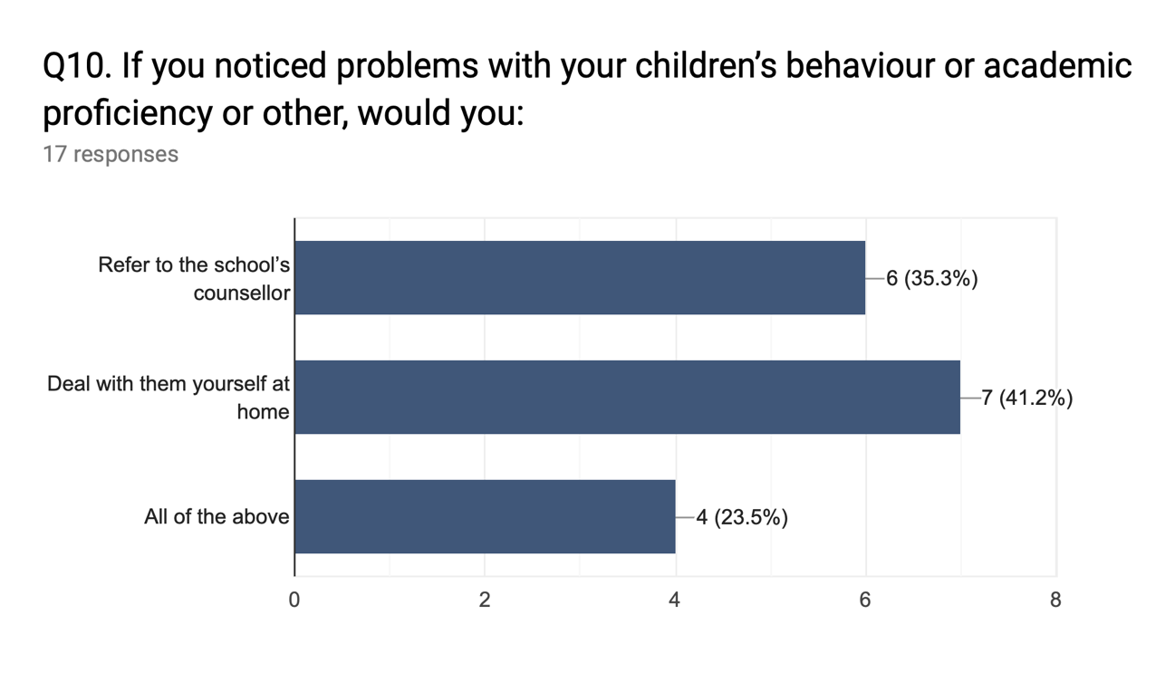

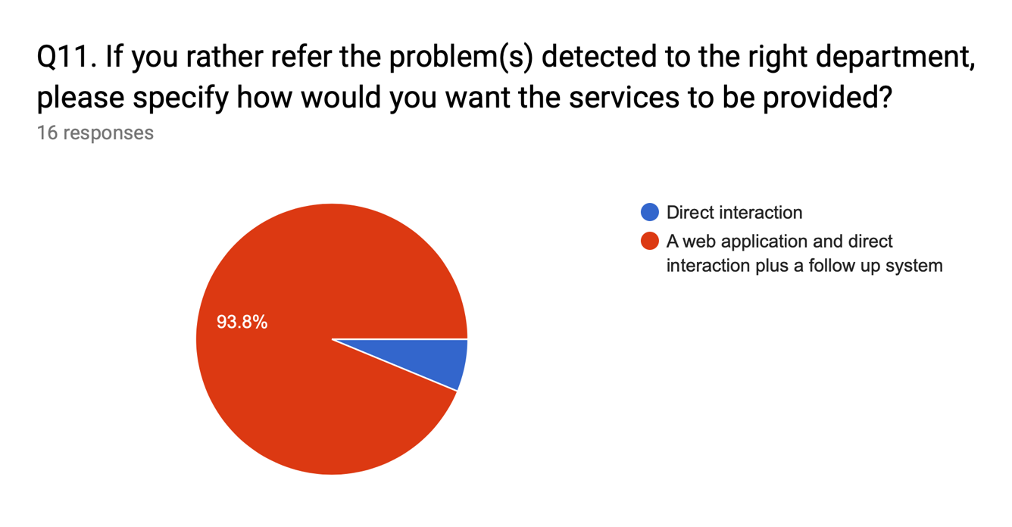

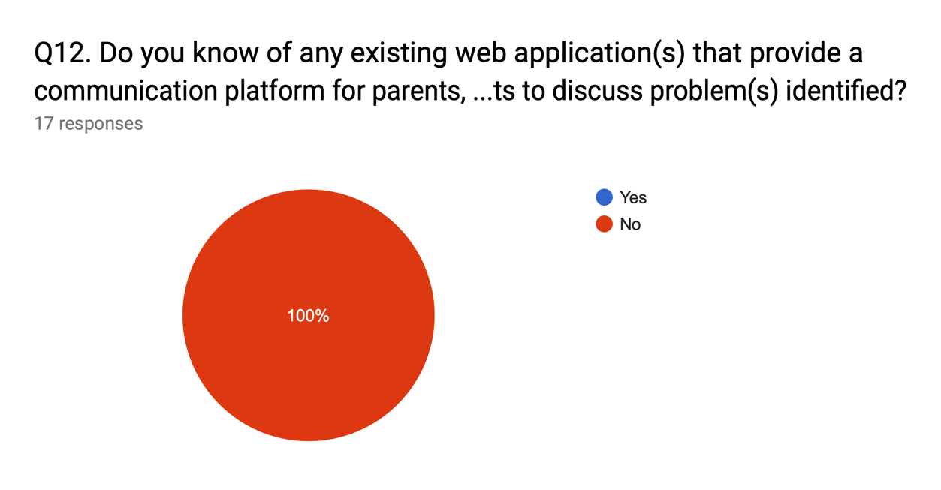

Q13. If you answered “Yes” to Q12, please provide the title and URL of such application.

0 responses

No responses yet for this question.

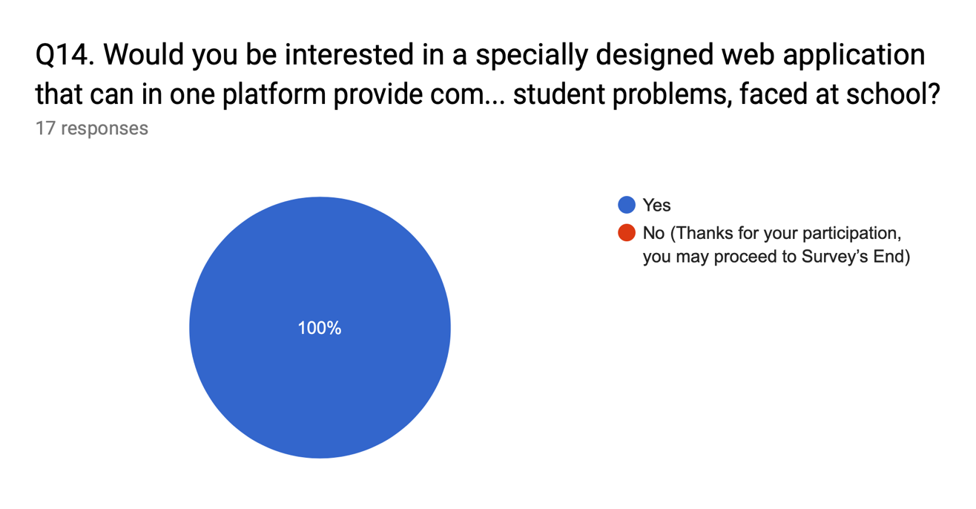

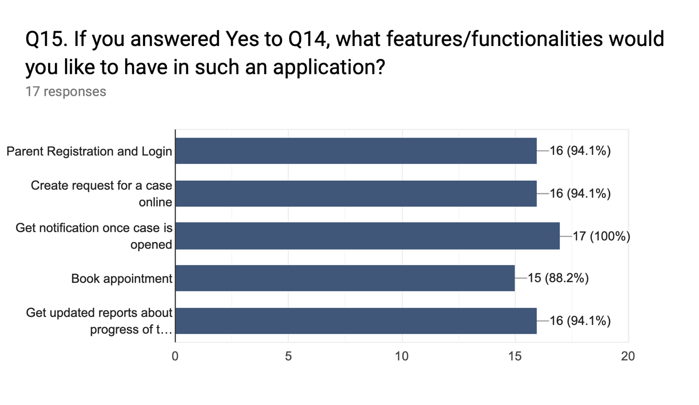

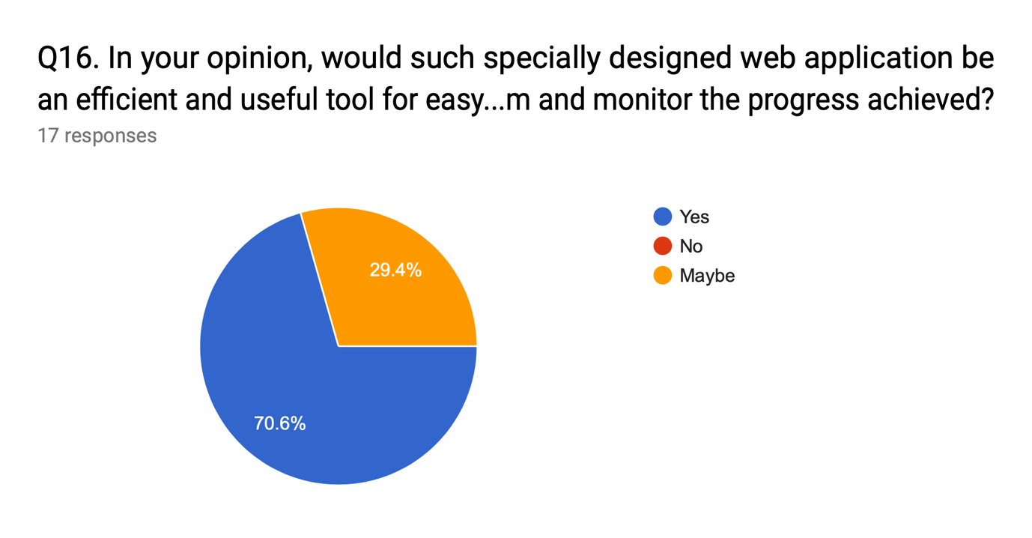

**Appendix A3: *Graphical Representation of the Structured Interview Results***

Q1. Please, state your Name and Surname

7 responses

Mrs Grace Idahosa

Mr Odigie Osagie

Mrs Mary Obeahon

Frank Maduka

Mrs Jane Idemudia

Mrs Vivian Oguamanam

Mr Patrick Ogbeide

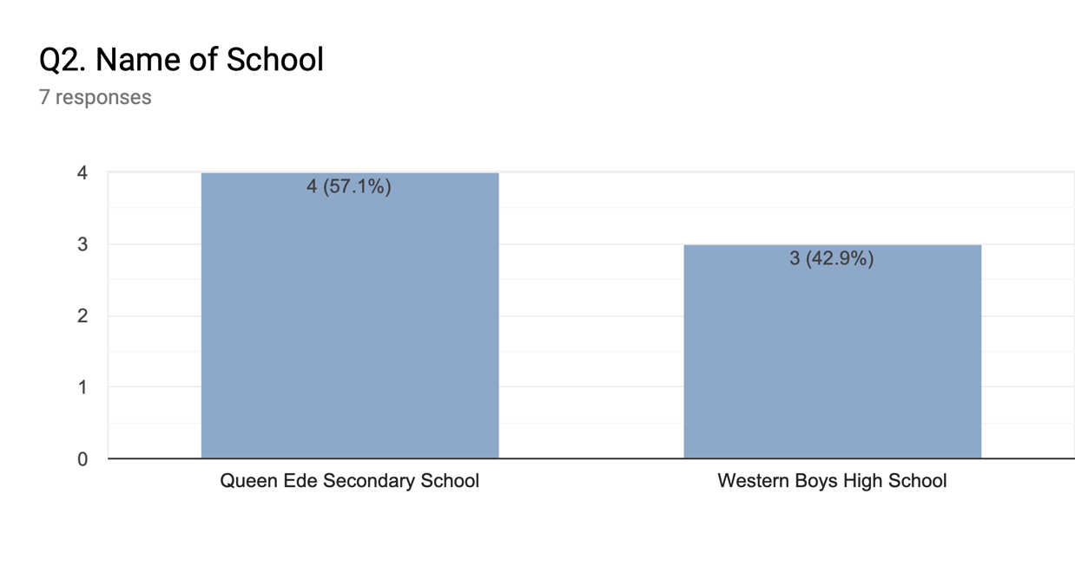

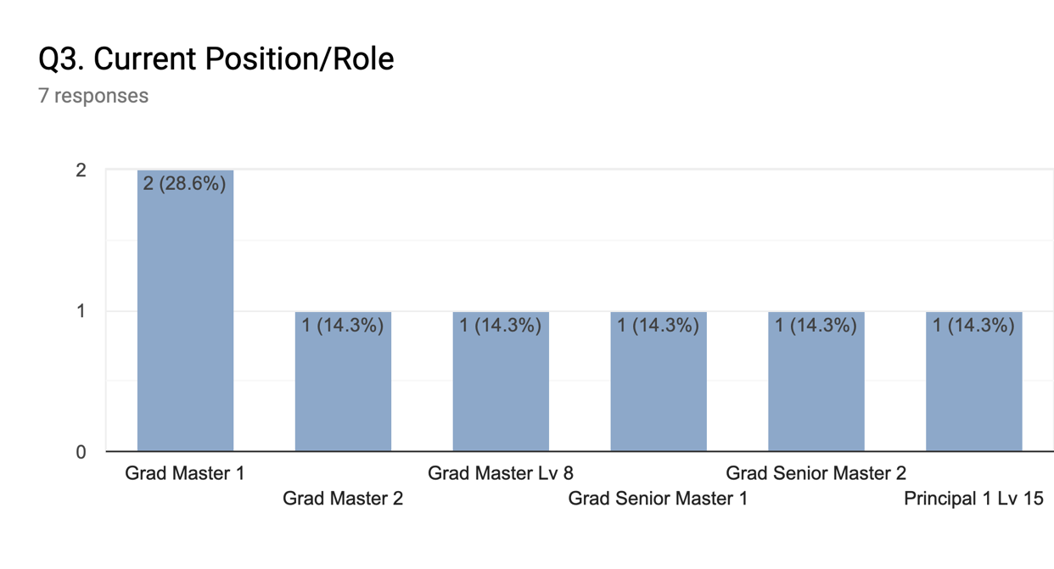

Q4. What subject(s) do you teach?

7 responses

Guidance And Counselling

Mathematics

Guidance And Counselling

Physics

Biology

English Language

Chemistry

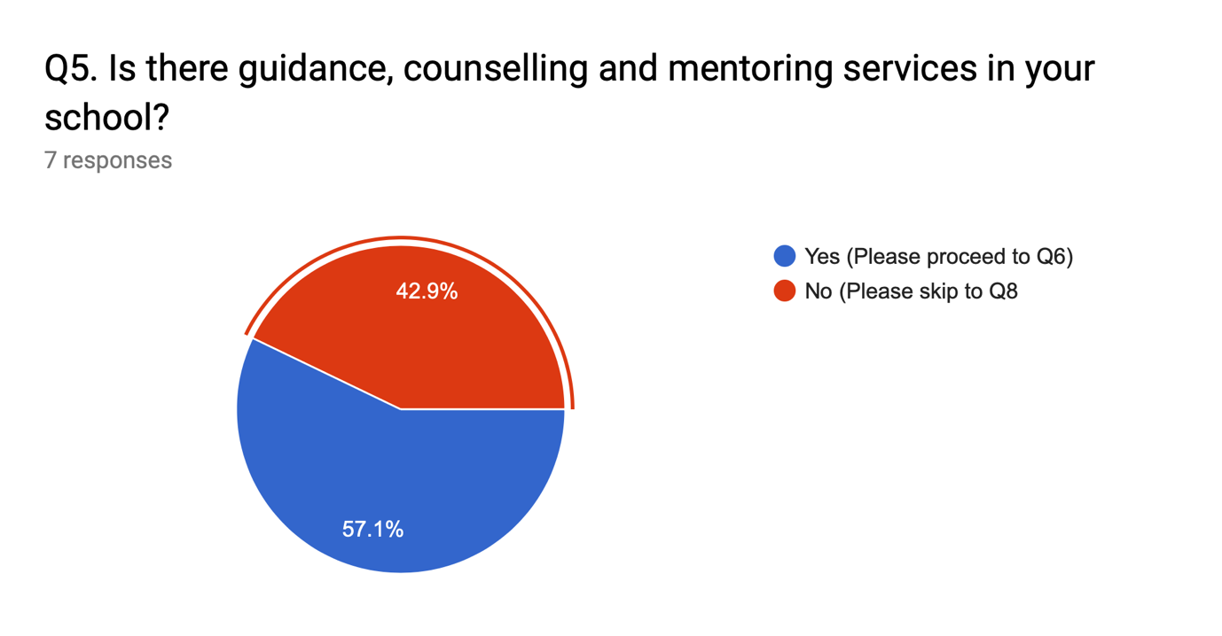

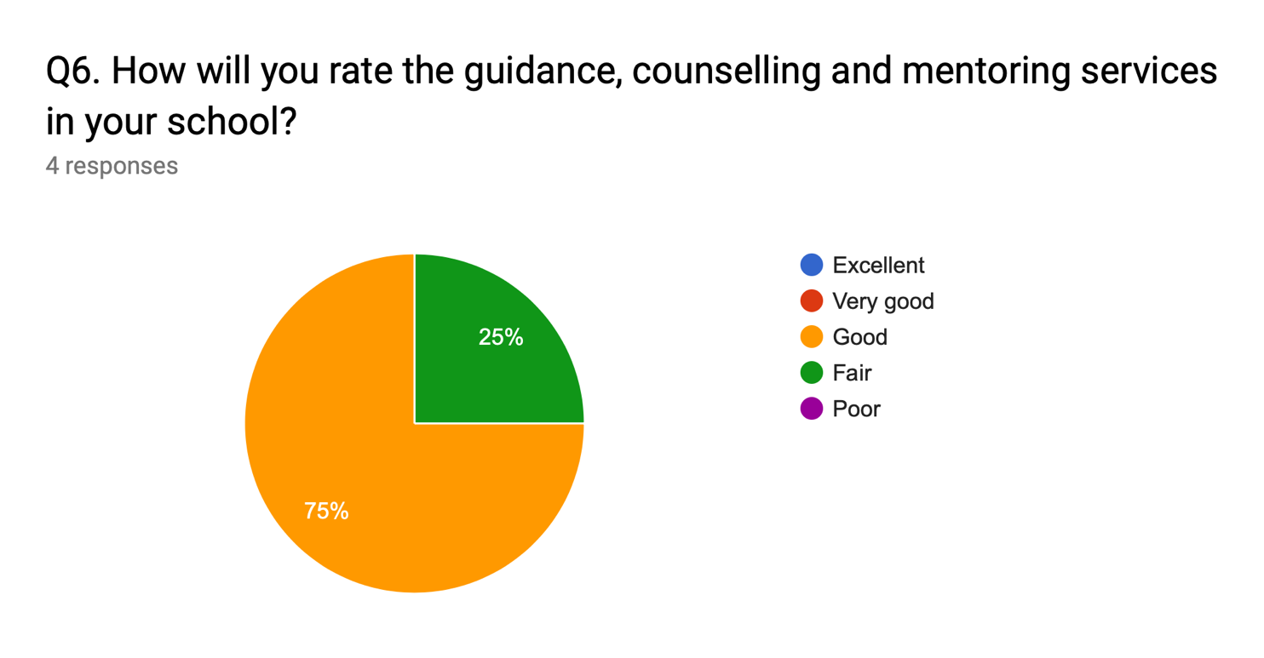

Q7. Please state what services are offered by the existing system

4 responses

Career Guidance, Academic Support and Moral Support

Career guidance, Academic support

Academic support, Career guidance, Moral support, Mental & Health wellbeing

Academic support and Career guidance

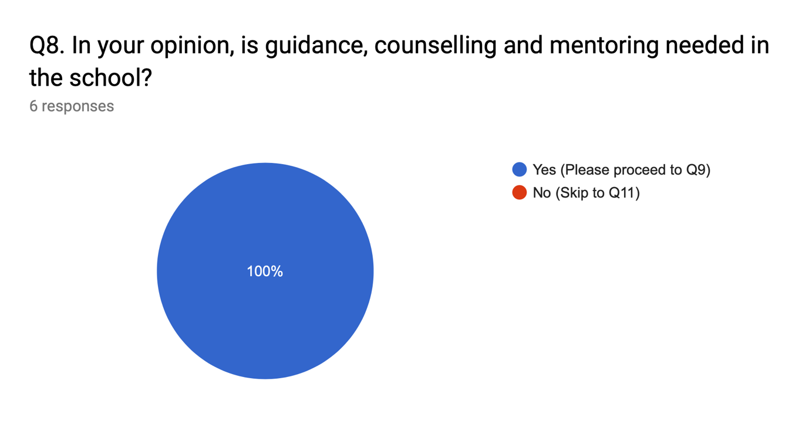

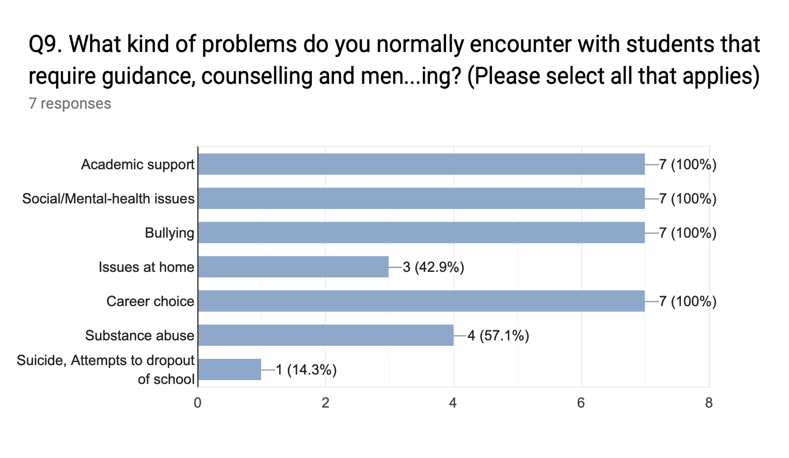

Q10. What challenges do you face In the course of offering guidance, counselling and mentoring services in your school?

4 responses

Parental influence on student's career choice and Overwhelming number of students to counsellor ratio

Budget limit of the department

Low budget provided for the department, Parents influence career choice of students

Thin budget of the guidance and counselling department

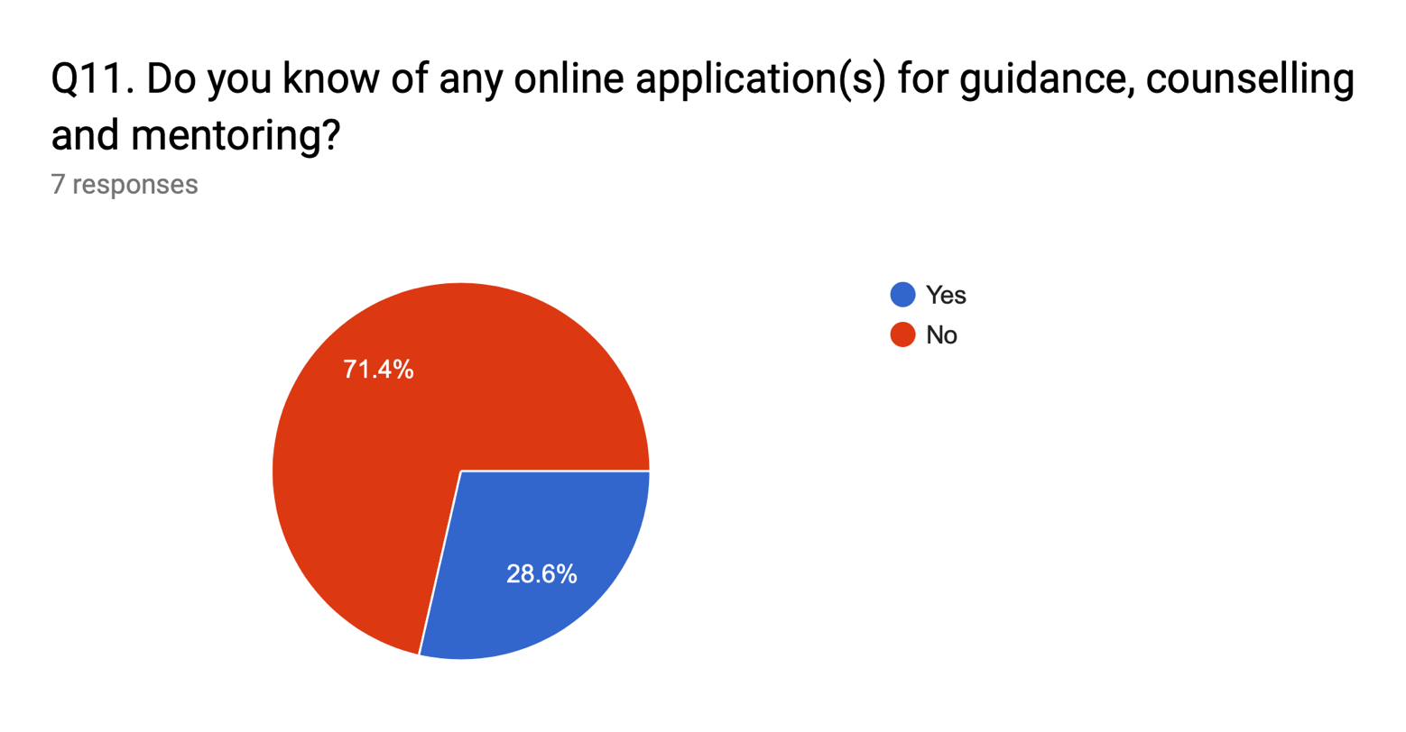

Q12. If you answered “Yes” to Q11, please provide the title and URL of such application.

2 responses

BetterHelp URL: <https://www.betterhelp.com>

turn2me URL: <https://turn2me.org>

Q13. If you answered “Yes” to Q11, please list some features and functionalities you liked in such an application.

2 responses

Questionnaire to understand the individual, Chat, Phone and Video sessions, Choice between online session or in-office visit

Support groups, 1-on-1 sessions with counsellor online, Questionnaire before each session

